Contents
1. INTRODUCTION and Rationale
2. The GATSBY BENCHMARKS
3. THE CURRICULUM
4. Role Of Careers Leader
5. DEFINITIONS
6. ACCREDITATION OPPORTUNITIES
7. IMPACT and REVIEW

Options Trent Acres School is a specialist, independent day school offering places to pupils aged 5 to 19. Places are offered to pupils who have complex needs including ASC, ADHD. A high number of our pupils may also have experienced early childhood trauma and may present with attachment difficulties.

The school operates across 2 sites within the Staffordshire borough and offers up to 141 across both facilities.

Options Trent Acres School, based in Kings Bromley is set within 12 acres of Staffordshire countryside. The full national curriculum is taught from key stage 1 to key stage 4, adapted to meet the needs of individual pupils. Post-16 pupils can access a range of qualifications, including additional GCSE’s and BTEC qualifications and a number of A-Level opportunities (please see Post-16 Policy for further information) The school is also home to a range of farm and domestic animals and reptiles who provide emotional support for pupils as well as curriculum enhancement. Additional opportunities to study animal care, land-based studies, equine studies, construction and engineering are also available to pupils.

Trent Acres - Brookfield is a purpose-built vocational college. We offer places for pupils aged 14 to 19, enabling them to study vocational routes into Hairy and Beauty, coding and music production and other vocational studies. Students will also be able to achieve Functional Skills in English, Mathematics and ICT from Entry Level to Level 2. Many of the staff will work across sites, providing consistency and stability for pupil.

INTRODUCTION and Rationale
A career is an individual’s journey through learning, work and other aspects of life. All young people need access to careers education, information, advice and guidance (CEIAG) to help them make informed career choices. Under the guidance of the department of education “all young people in secondary school get a programme of advice and guidance that is stable, structured and delivered by individuals with the right skills and experience” careers guidance and access for education and training providers – statutory guidance for governing bodies, school leaders and school staff January 2018 to achieve this aim, the careers strategy sets out that every school and academy providing secondary education should use the Gatsby foundations benchmarks to develop and improve their CEIAG programme.
Trent Acres Careers provision is committed to providing a planned programme of Careers Education, Information, Advice and Guidance for all pupils in years 7 to 13.

This policy has been produced using guidance from:

• Careers guidance statutory guidance 2023
• Education Act 1997
• Apprenticeships, Skills, Children and Learning Act 2009
• Equality Act 2010
• Children and Families Act 2014
• Provider Access Legislation (PAL) 2023

THE GATSBY BENCHMARKS
We use the Gatsby Benchmarks to develop and improve our careers provision and to ensure we fulfil our legal duties. For further information about how we are working towards these benchmarks at Options Trent Acres please refer to our action plan.

- Have a stable careers programme - An embedded programme of career education and guidance that is known and understood by pupils, teachers, parents/carers, employers, and other agencies.

- Learn from career and labour market information - Every pupil and their parents/carers, to have access to good quality information about future study options and labour market opportunities. This will include the support of an informed adviser to make the best use of available information

- Addressing the needs of each pupil - Pupils have different career guidance needs at different stages. Opportunities for advice and support tailored to the needs of each pupil. Our careers programme ensures equality and diversity is embedded throughout.

- Linking curriculum learning to careers - All teachers and support staff link curriculum learning with careers, even on subject areas that may not be specifically occupation-led. For example, STEM subjects should have their relevance highlighted and linked to the wide range of future career paths. Learning programmes should also reflect the importance of Maths and English as a key expectation from employers.

- Encounters with employers and employees - Every pupil should have multiple opportunities to learn from employers about work, employment and the skills that are valued in the workplace. This will be through a range of enrichment activities, including visiting speakers, mentoring and enterprise schemes, and include pupils’ own part-time employment where it exists / is possible.

- Experience of workplaces - Every pupil to have first-hand experiences of the workplace through work visits, work shadowing and/or work experience to help their exploration of career opportunities and expand their networks.

- Encounters with further and higher education - All pupils should understand the full range of learning opportunities that are available to them. This includes both academic and vocational routes, and learning in schools, colleges, universities and in the workplace.

- Personal guidance Every pupil should have opportunities for guidance interviews with a level 6 qualified careers adviser provided they are trained to an appropriate level. These will be available for all pupils and appropriate to the individual needs and developmental stage.

THE Careers CURRICULUM
At Options Trent Acres School, we recognise and celebrate that all our young people will all have different aspirations for their futures and as a result their educational transitions and career pathways will need to be planned on an individualised basis. Careers education for pupils at Options Trent Acres School will be relevant and specific and planned and delivered carefully to meet their individual needs.
Careers education and guidance rely heavily on collaborative and partnership activities and interventions between a range of ‘careers influencers’ including learners themselves, parents and carers, other learning providers, and business and community organisations. Options Trent Acres School is fully supported by our regional adviser who helps provide a bespoke service, tailored to the needs of the individual, periodically throughout the school year.
Career(s) guidance, for individuals and small groups, focuses on careers information, advice and support. It may include counselling and coaching. It enables individuals to accomplish the unique tasks and issues they face in making progress and achieving their aspirations.
All pupils will also receive personalised guidance from our Level 6 qualified regional careers advisor.
Guidance provided is:
- Accurate and up to date
- Presented in an impartial manner
- Enables them to make informed choices about broad range of career options
- Helps to encourage them to fulfil their potential
All pupils at Options Trent Acres have a progressive curriculum related to each area of the Gatsby benchmarks which are shared with pupils and then worked towards throughout the academic year.
Careers and work-related education share close and overlapping concerns which justify the development of a single and integrated framework. Options Trent Acres School subscribes to its responsibilities within our group framework.
- Grow throughout life
- Explore possibilities
- Manage career
- Create opportunities
- Balance life and work.
- See the big picture.
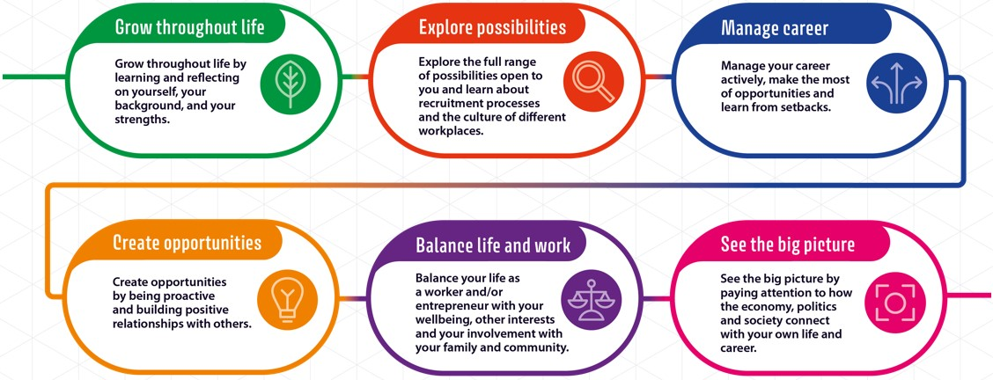
Work Experience and Work-Related Education
Work-related education enables children and young people to learn the knowledge, skills and attitudes that will enable them to understand and succeed in the world of work. It makes extensive use of employer engagement to deliver active and experiential learning activities in and beyond the classroom. Options Trent Acres School is forging strong links with our local community across a variety of sectors, allowing pupils to benefit from rich experiences and make informed choices about their next steps.

ACCREDITATION OPPPORTUNITIES
At present we are using the Kings Trust. However, our Careers Education and Work-Related Learning is constantly reviewed and updated.
From 2026 we will be using NCFE and the AQA Award.
The Kings Trust qualification in Personal Development and Employability Skills covers the personal skills, qualities and attitudes required by employers across a range of sectors. The Kings Trust Careers Framework in schools is designed to equip students with essential skills and knowledge for future careers. It includes a range of units that cover personal development, employability skills, and practical skills relevant to various sectors. The framework aims to prepare students for adult life by focusing on key areas such as managing money, considering career options, experiencing the world of work, and learning digital skills.
Students are encouraged to develop their ideas orally and in writing, read a variety of non-fiction texts, and participate in individual and group projects. The framework also emphasizes the importance of teamwork, communication, and digital skills, which are crucial for success in the workforce.
The Kings Trust curriculum is trauma-informed and addresses topics that require a trauma-informed approach, ensuring that all students are supported in their learning journey. The framework is designed to be accessible to all students, regardless of their ability or background, and aims to remove barriers to learning.

The Role of the careers leader

All statutory elements of the curriculum are met.
• The amount of time for teaching the curriculum is adequate and reviewed annually.
• A positive learning culture in which all children believe that they can succeed is promoted
in school.
• There are high standards of teaching and learning.
• The school is compliant with legislation and to enable an annual evaluation of Careers
within the school.
• The guidance is followed in line with an annual appropriate careers audit using the Gatsby
career benchmarks and update, when necessary, throughout the year.
• They attend termly Careers Leader conferences to gain ideas and network
amongst other schools.
• Annual audits are completed to monitor achievement of benchmarks and quality of careers
learning.
• Pupils have access to a deep learning careers week.
• Appropriate accredited courses are followed where applicable.
• Pupils have the opportunity for individual, impartial careers guidance interviews with
experienced staff at key decision points.
• Subject resources are kept up to date and available for all staff.
• Teaching of careers is relevant across all stages in school.
• Pupils have access to encounters with a variety of employers and businesses.
• Relevant FE providers have access to pupils from year 7 to 13 to inform them about the
varied career options open to them and courses and qualifications they offer and what each
option entails.
Class teachers must ensure that:
• Pupils gain an understanding of the world of work and will understand their entitlement to

• Pupils know and understand how to access sources of career/post school information and
decision-making support.
• Each student has a careers portfolio which is kept up to date.
• Gather evidence in relation to key areas of the career curriculum.
• Pupils have access to a variety of opportunities in investigating other careers, e.g. self-employment.
• Pupils have an awareness of a variety of paths that they can follow to achieve
success in a chosen employment area.

Impact And EVALUATION
As with all policies we constantly review our delivery and provision. At present we use a careers tracker to monitor pupil Destinations. However, we are broadening our approach to use

- Data Tracking
- Pupil Voice
- Parent Forums
- Teacher evaluations.

We are also looking to widen access via careers fairs, work experience and employer engagement.

This policy will be reviewed on an annual basis or more frequently where necessary.

Policy Reviewed by: | James Russell | Signature: J. Russell | Date: March 2026
Headteacher: | Phil Petch | Signature: | Date: March 2026
Next Review Date: | September 2026 | Last Reviewed:

