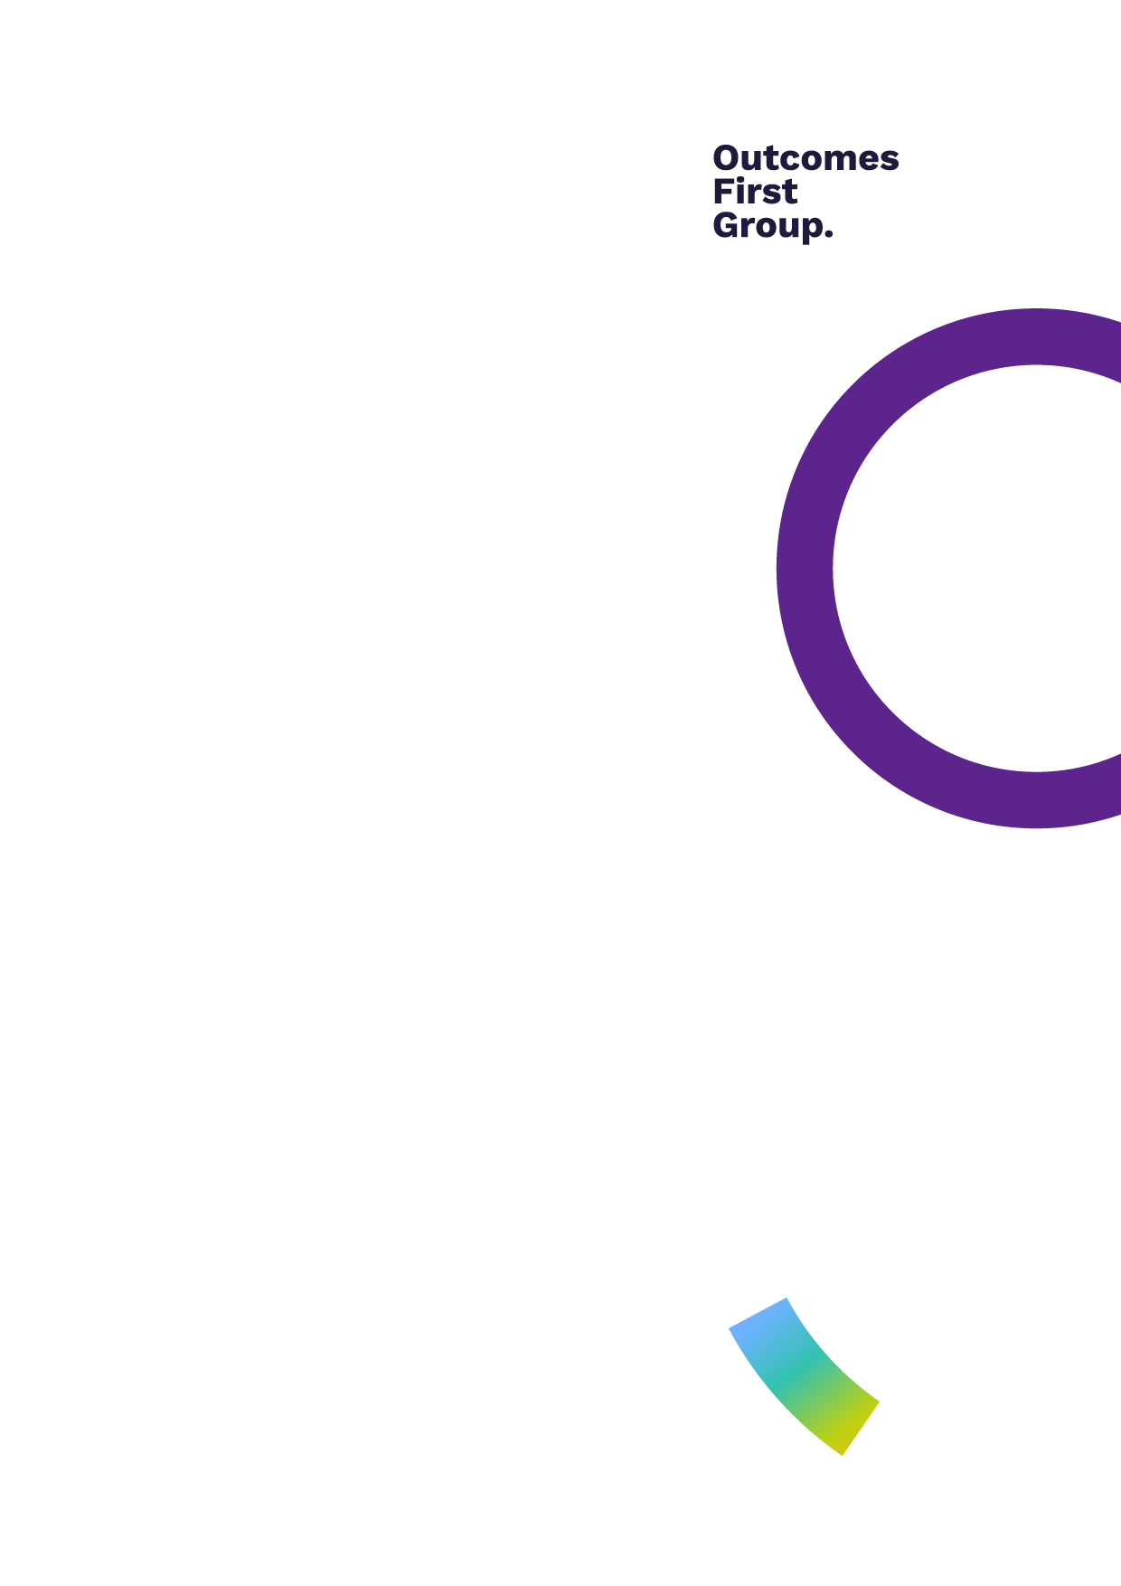

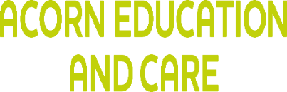
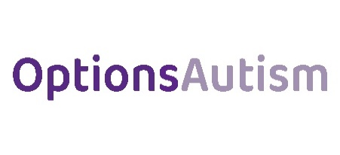

HARMFUL SEXUAL BEHAVIOUR (HSB)
GUIDANCE
Children’s Education and Care

OPTIONS TRENT ACRES SCHOOL
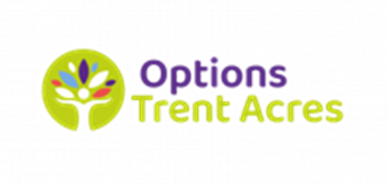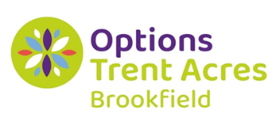

Contents

1.0 Purpose of this guidance 2
2.0 Our approach 2
3.0 What is Harmful Sexual Behaviour? 2
4.0 Stages of sexual development 3
5.0 Understanding sexual behaviour 4
6.0 Risk Factors 4
7.0 Response 5

1.0 Purpose of this guidance

This guidance provides information to help staff understand, identify and respond to Harmful Sexual Behaviour (HSB) experienced or displayed by children and young people. It is an additional document to the setting’s Child-on-Child Abuse Policy and must read and applied alongside that policy and the setting’s Safeguarding Policy.

2.0 Our approach

A contextual safeguarding approach will be taken to understand, and respond to, any occurrences of harmful sexual behaviour, recognising that children and young people who display harmful behaviours must be seen as vulnerable themselves.

3.0 What is Harmful Sexual Behaviour?

Harmful sexual behaviour can include children and young people using sexually explicit words or phrases, inappropriate touching, using sexual violence or threats, penetrative sex with other children/young people. Sexual violence and sexual harassment exist on a continuum and may overlap; they can occur online face-to-face (both physically and verbally) and are never acceptable.

Sexual violence and sexual harassment can occur between two children of any age and sex. From primary through to secondary stage and into colleges. It can occur through a group of children sexually assaulting or sexually harassing a single child or group of children.

All staff working with children and young people are advised to maintain an attitude of ‘it could happen here.” Schools/ colleges/homes should be aware of and respond appropriately to all reports and concerns about sexual violence and/or sexual harassment both online and offline, including those that have happened outside of the school/college/home.

Age and stages of development of children and young people are critical factors in harmful sexual behaviour; however, it is not defined by these factors. Sexual behaviour between children can be considered harmful if one of the children is much older, particularly if there is more than two years’ difference or if one of the children is pre-pubescent and the other is not. However, a younger child can abuse an older child, particularly if they have power over them, for example, if the older child is disabled, smaller in stature or has other vulnerabilities. Power is a key factor in the reasons why young people display harmful sexual behaviours towards other children. Evidence shows that girls are more likely to be subject to sexual violence and sexual harassment than boys, and that boys are more likely to perpetrate such violence and harassment, however either gender can be victim or perpetrator.

The importance of distinguishing between problematic and abusive sexual behaviour (Harmful Sexual Behaviour) is recognised. Understanding where a child's behaviour falls on a spectrum is essential to being able to respond appropriately to it.
3.1 Definition

The NSPCC defines Harmful Sexual Behaviour (HSB) as: "Developmentally inappropriate sexual behaviour which is displayed by children and young people, and which may be harmful or abusive (derived from Hackett, 2014) it may also be referred to as sexually harmful behaviour or sexualised behaviour… may be harmful towards self or others or be abusive towards another child…or adult."
Please see: Harmful Sexual Behaviour Framework for the full Harmful Sexual Behaviour Framework developed by NSPCC in partnership with Research in Practice, Durham University and the NHS.

The Brook Traffic Light Tool helps staff to identify, assess and respond appropriately to sexual behaviours. As a minimum, DSLs and Safeguarding Leads, and their deputies should complete the Brook e-learning: Sexual Behaviours Traffic Light tool

Simon Hackett (2010) proposes a Continuum Model of Behaviours to demonstrate the range of sexual behaviours presented by children and young people, from those that are normal, to those that are highly deviant. However, assessing where behaviour fits on this continuum can be complex. It is important to place any child’s sexual behaviour within a developmental context and recognise the key differences between the motivations and meanings of such behaviours at varying stages of development.

4.0 Stages of sexual development

It is important that anyone who works with children and young people has a good understanding of how children develop sexually. This can help in recognising healthy sexual behaviours that are developmentally appropriate and identifying if a child is displaying behaviour that is inappropriate or potentially harmful.

Sexual development begins in infancy and is a natural part of growing up. Some children may develop later or earlier than others depending on their understanding, their own overall development and environment. The NSPCC provides some examples of age-appropriate healthy sexual behaviour.
0- to 4-years-old

At this stage, children display natural exploratory behaviour emerging for the first time such as:
- enjoying being naked
- kissing and hugging people they know well, for example friends and family members
- touching or rubbing their own private parts as a comforting habit
- showing curiosity about or attempting to touch the private parts of other people
- being curious about the differences between boys and girls
- talking about private body parts and their functions, using words like ‘willy’, ‘bum’, ‘poo’
- role playing about different relationships, for example marriage.

5- to 9-year-olds

As children get a little older, they become more conscious of sex and their own sexuality. This can be displayed by:
- becoming more aware of the need for privacy
- asking questions about sex and relationships, such as what sex is, where babies come from and same-sex relationships
- kissing, hugging and holding hands with a boyfriend or girlfriend
- using swear words or slang to talk about sex after hearing other people use them.

9- to 13-year-olds

During these ages, children begin to get more curious about sex. Examples of healthy sexual behaviour during this stage are:
- having a boyfriend or girlfriend (of the same or different gender)
- using sexual language as swear words or slang
- wanting more privacy
- looking for information about sex online (this might lead to accidentally finding sexual pictures or videos)
- masturbating in private

13- to 17-year-olds

During adolescence, sexual behaviour becomes more private with young people, and they begin to explore their sexual identity. They might be:
- forming longer-lasting sexual and non-sexual relationships with peers
- using sexual language and talking about sex with friends
- sharing obscenities and jokes that are within the cultural norm
- experimenting sexually with the same age group
- looking for sexual pictures or videos online.

For further information, please visit: NSPCC Sexual Development and behaviour in children

5.0 Understanding sexual behaviour

It is essential that those working with children and young people can distinguish normal from abnormal sexual behaviours. Hackett’s (2010) continuum model demonstrates the range of sexual behaviours presented by children and young people, from those that are normal, to those that are highly deviant.

Healthy sexual behaviours are:
- Developmentally expected and age appropriate
- Socially acceptable
- Consensual, mutual, reciprocal
- Shared decision making

Problematic Sexual behaviours are:
• Problematic and concerning behaviours
- Developmentally unusual and socially unexpected
• No overt elements of victimisation
• Consent issues may be unclear
• May lack reciprocity or equal power and may include levels of compulsivity

Abusive Sexual behaviours are:
- Victimising intent or outcome
- Includes misuse of power
- Coercion and force to ensure victim compliance, may include elements of expressive violence
- Intrusive
- Informed consent lacking, or not able to be freely given by victim

Sexual harassment between children/young people means ‘unwanted conduct of a sexual nature’ . It can occur online and/or face to face and can occur simultaneously between the two. Sexual harassment is likely to violate a child’s dignity, and/or make them feel intimidated, degraded or humiliated and/or create a hostile, offensive or sexualised environment.

All staff should recognise that children are capable of abusing other children, in the online and offline worlds. Staff should be clear about their setting’s policy and procedures with regard to child-on-child abuse (Please see Child-on-child Policy).

6.0 Risk Factors

'Peer relationships are increasingly influential during adolescence, setting social norms which inform young people’s experiences, behaviours and choices and determine peer status. These relationships are, in turn, shaped by, and shape, the school, neighbourhood and online contexts in which they develop. ' (Contextual Safeguarding Briefing, Dr Carlene Firmann, 2017). Young people's peer groups, communities and social media activity can be either key risk factors or key protective factors.
Children and young people can develop harmful sexual behaviours because of trauma or abuse. They may have experienced:
- Physical abuse, emotional abuse and/or sexual abuse
- Severe neglect
- Parental rejection
- Family breakdown
- Domestic abuse
- Parental substance misuse

It is important to remember that being abused does not mean that children or young people will go on to abuse others.

Key risk factors and vulnerabilities of young people who sexually abuse others are that they may:
- have poor self-regulation and coping skills
- experience social anxiety and a sense of social inadequacy
- have poorly internalised rules for social behaviour
- possess a poorly developed or primitive sense of morality
- lack secure and confident attachments to others
- exercise limited self-control, and act out their emotional experiences through negative or otherwise inappropriate behaviour
- have little insight into the feelings and needs of others and, indeed, their own emotions
- place their own needs and feelings ahead of the needs and feelings of others
- exhibit a poorly defined sense of personal boundaries have developed strong and not easily corrected cognitive distortions about others, themselves, and the world they share
- struggle to interact socially or have issues with social competence.
Staff must remember this is not an exhaustive list and must remain alert to possible signs of sexual abuse, violence, harassment or harmful behaviours by children and young people.

For children and young people with special educational needs or disabilities (SEND), and multiple complex co-occurring needs, it can be difficult for staff to distinguish between signs of abuse and behaviour that is part of the child or young person’s condition. Staff should be alert to changes in their behaviour and always consider all possible causes of this. Please also see: Children with disabilities - Safeguarding our most vulnerable

The Lucy Faithfull Foundation has developed a HSB Toolkit, which provides support, advice and information on how to prevent it, links to organisations and helplines, resources about HSB by children, internet safety, sexual development and preventing child sexual abuse.
Please also see: NICE guidance: Harmful sexual behaviour among children and young people

7.0 Response

Staff must follow Section 4.0 Responding to Alleged Incidents and Concerns of the Child-on-Child Abuse Policy if they have any concerns, or if a child or young person discloses that they have been harmed.

Staff must act immediately and report any concerns regarding child-on-child abuse to the DSL /Safeguarding Lead or their deputies, within one working day, and document this on the electronic recording system.

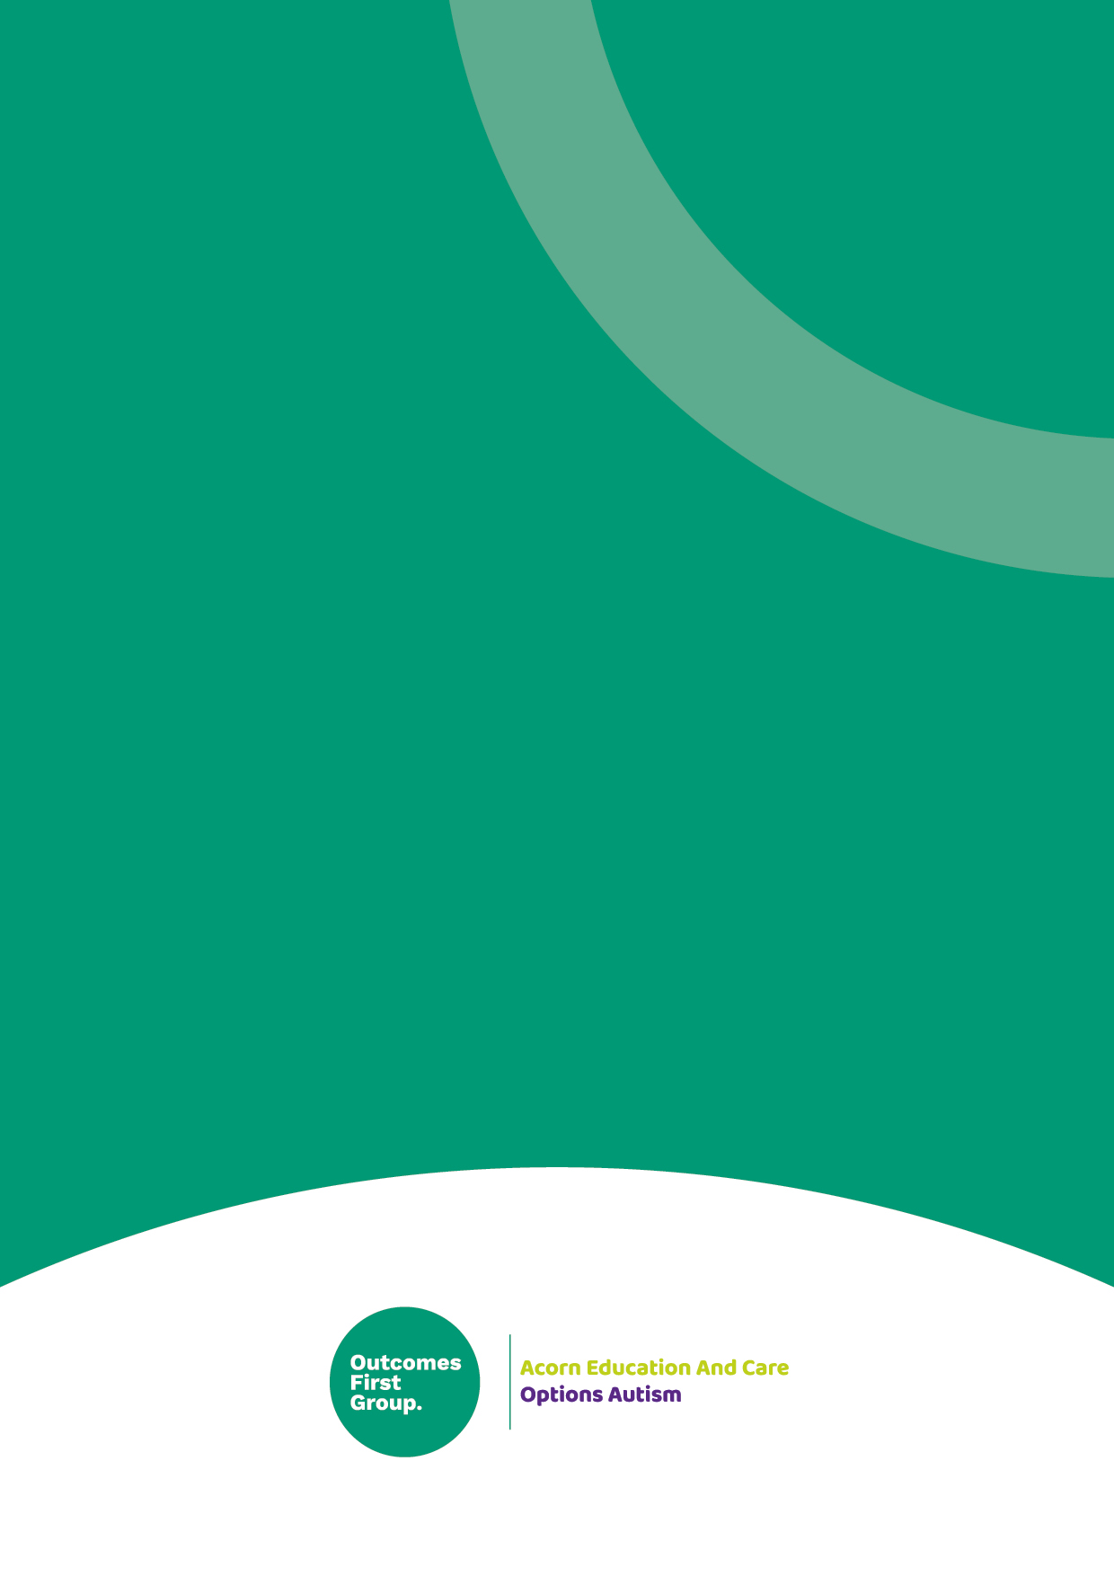

We are part of the Outcomes First Group Family, by
working together we will build incredible futures
by empowering vulnerable children, young people
and adults in the UK to be happy and make their
way in the world.

